function y = mysinc(x)

% mysinc - Compute the sinc function (as defined in the lecture notes)

% sinc(x) returns a matrix whose elements are the sinc of the

% elements of x

% Initialize the output array to all ones.

y = ones(size(x));

% Determine the indices of all nonzero elements in the input array.

i = find(x);

% Compute the sinc function for all nonzero elements.

% The zero elements are already covered, since the output

% array was initialized to all ones above.

y(i) = sin(x(i)) ./ (x(i));

return

function Fourier()

clear all

for n = [1 5 10 50 100]

% Sum terms

syms k w

f = symsum(sym('0.5 * mysinc(pi * k / 2) * exp(j * k * w * t)'),...

k, -n , n);

% Plot the sum

ezplot(subs(f,w, 2 * pi), [-1 1]);

% label the graph

title(sprintf('x_{%d}(t)', n));

% advance to the next figure on keypress

w = waitforbuttonpress;

if w == 0

disp('Button click')

else

disp('Key press')

end

% print the picture to a file

print(sprintf('x_{%d}(t)', n), '-dpng');

end

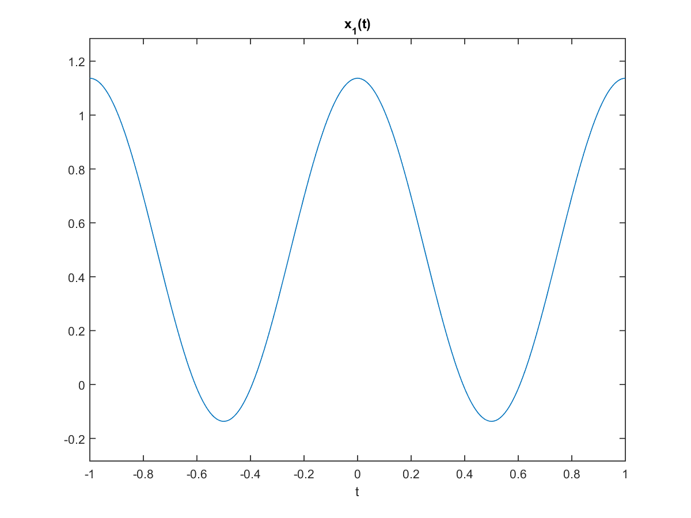>> Fourier()

